**Jenkins – Task**

1) Install Jenkins and run Jenkins on port number 8081.  
2) Secure Jenkins server  
3) Create users called DevOps, Testing in Jenkins with Limited access.  
4) Configure labels and restrict the jobs to execute based on label only.  
5) Create Three sample jobs using the below URL.  
   <https://github.com/betawins/Techie_horizon_Login_app.git>  
6) Create one Jenkins job using git hub Private repository.

GitHub**GitHub**

[**GitHub - betawins/Techie_horizon_Login_app**](https://github.com/betawins/Techie_horizon_Login_app.git)

Contribute to betawins/Techie_horizon_Login_app development by creating an account on GitHub. (33 kB)

1Q: Install Jenkins and run Jenkins on port number 8081.

Step 1: Create instance

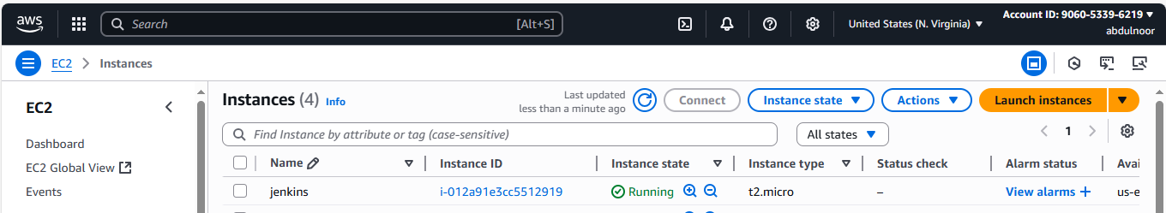

Keep 20 gb storage

Step 2 : connect to instance: through Gitbashhere

Step3: switch to root user

Sudo su –

Step4: check the java version

java –version

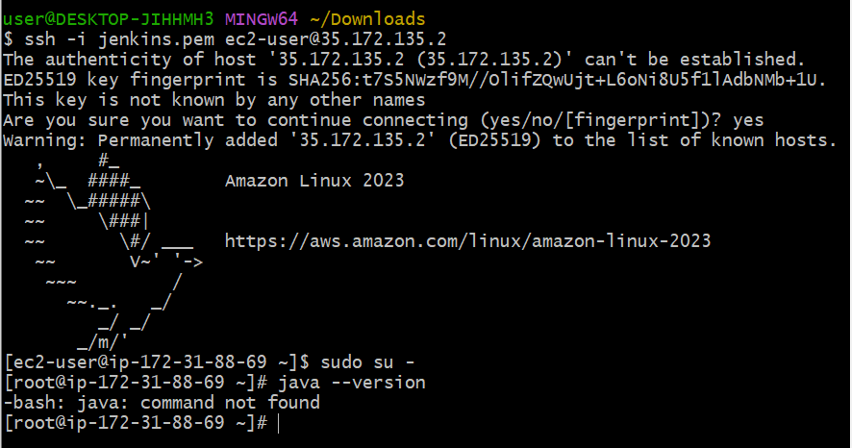

Java command not found why ?

Because java in not installed in our EC2

Go to google

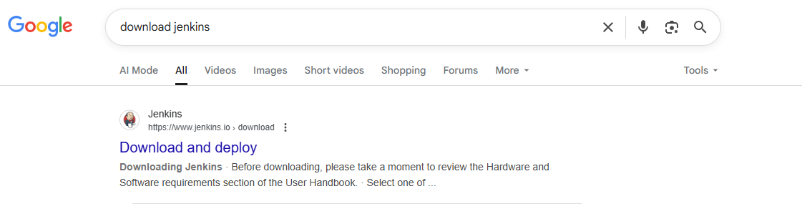

Click on this

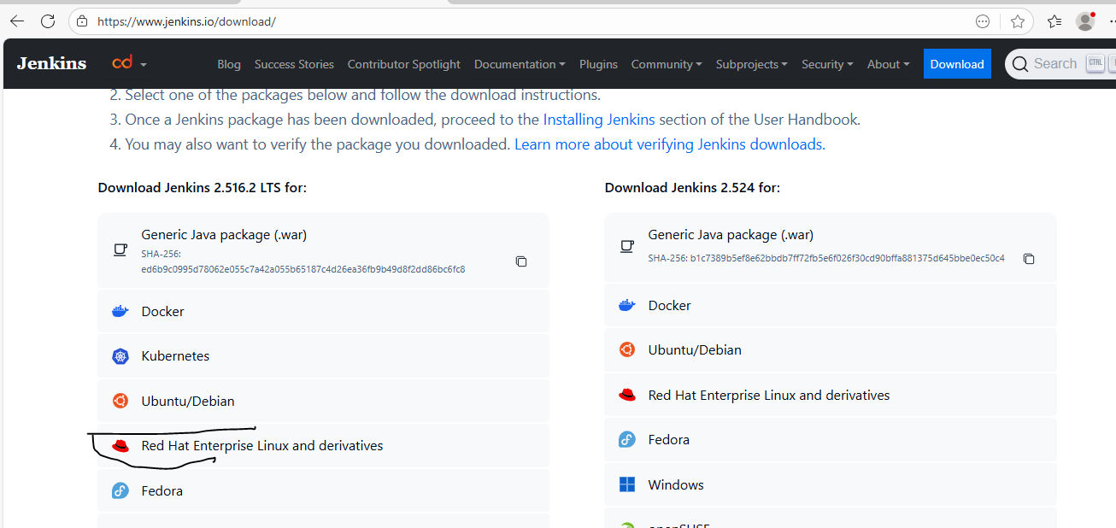

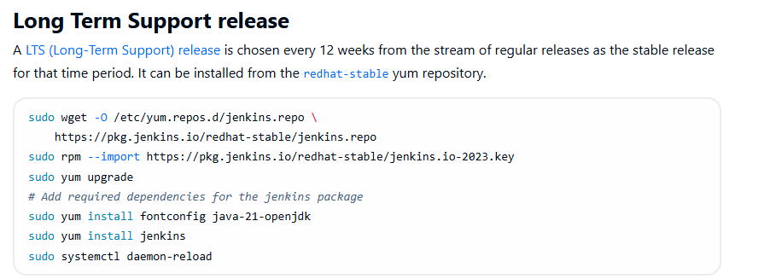

Beore downloading this I need to install package If install without having pakage it wont install

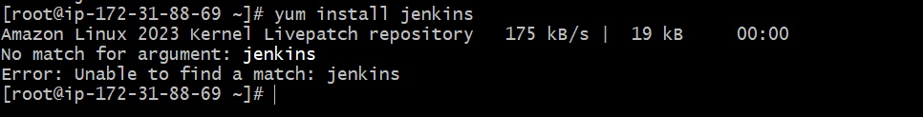

It say above error

So we need to download the packages first

sudo wget -O /etc/yum.repos.d/jenkins.repo <https://pkg.jenkins.io/redhat-stable/jenkins.repo>

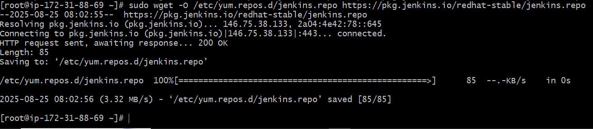

sudo rpm --import https://pkg.jenkins.io/redhat-stable/jenkins.io-2023.key



This is also downloaded

Now install java 17 (because it is recommended for Jenkins)

sudo yum install -y fontconfig java-17-openjdk

The error No match for argument: java-17-openjdk means your OS repositories currently don't have the **OpenJDK 17** package available by that name.

This usually happens if you're on **Amazon Linux 2** or a **minimal RHEL/CentOS** setup where the default repos don't include Java 17

So use the below command

sudo yum install java-17-amazon-corretto

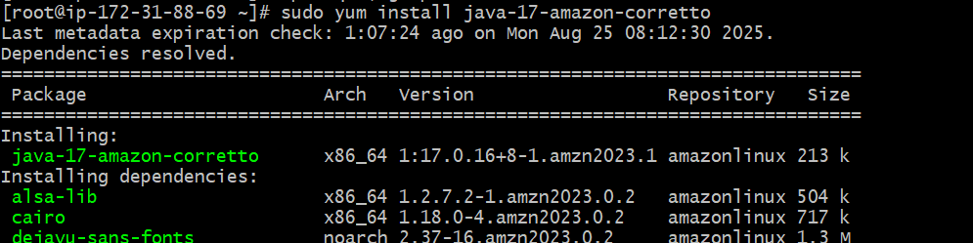 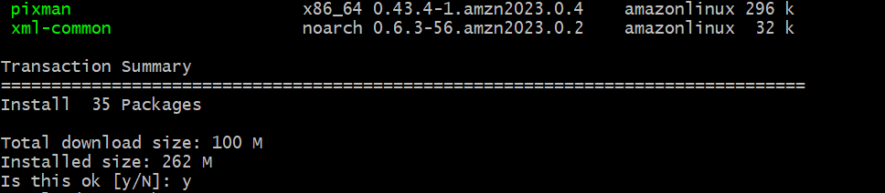 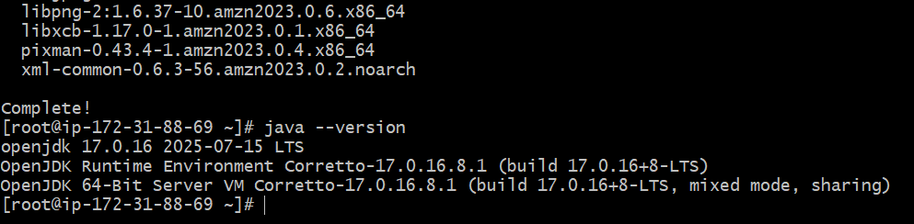

Now install Jenkins

yum install jenkins

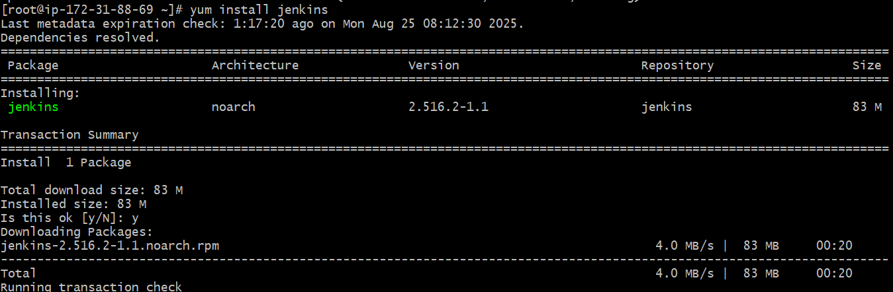 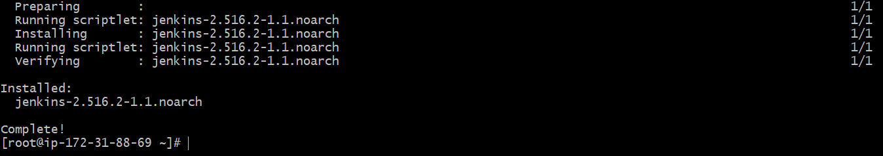

Systemctl status jenkins

Systemctl start jenkins

Systemctl status jenkins

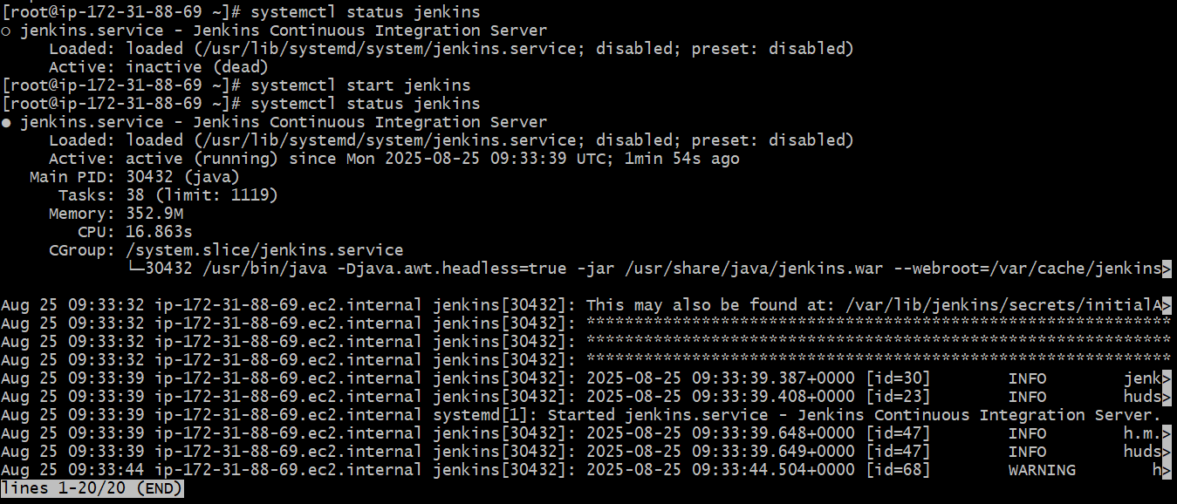

Check deault location of Jenkins by entering in directory, where we all related iles of Jenkins

cd /var/lib/jenkins/

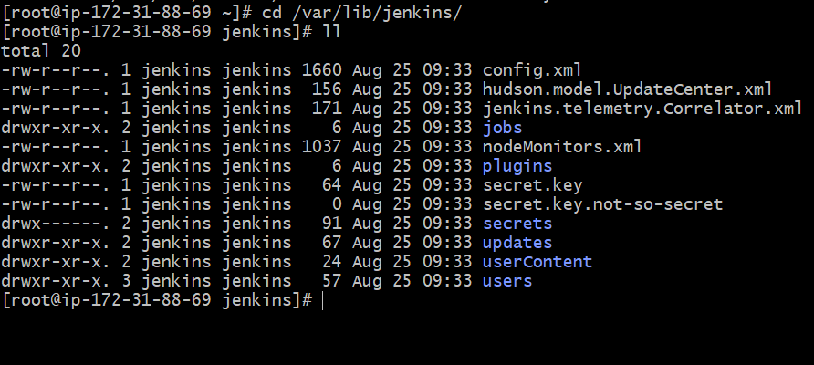

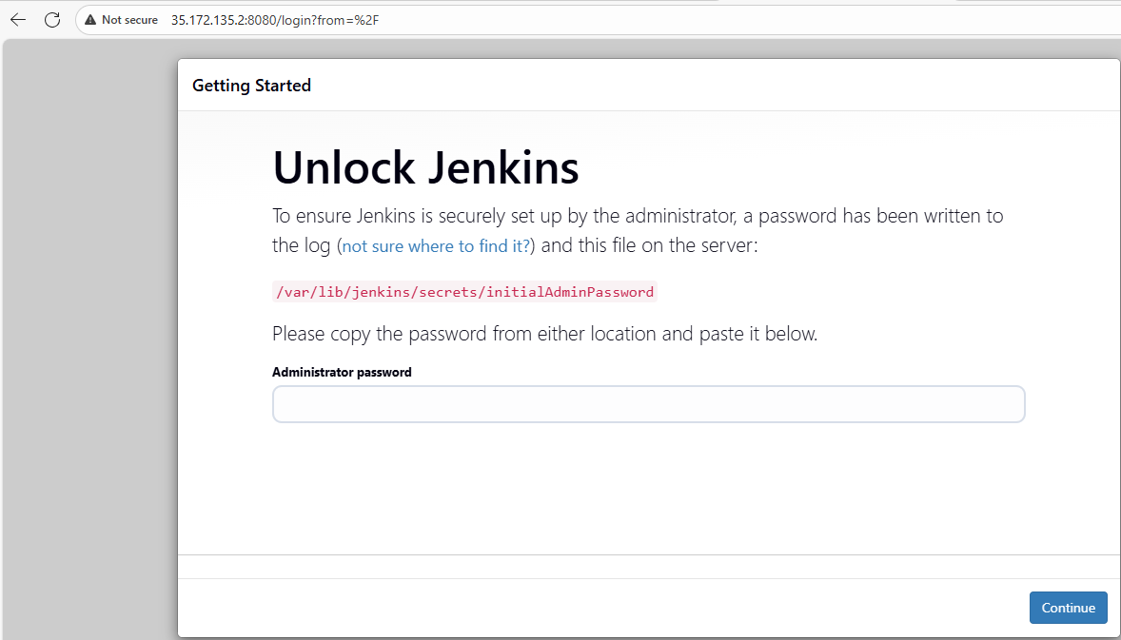

Now how to access Jenkins : entering public ip and port number 8081

1. **Now go to → sudo vi /usr/lib/systemd/system/jenkins.service**
2. **Update → Environment="JENKINS_PORT=8081"**
3. **sudo systemctl daemon-reexec**
4. **sudo systemctl daemon-reload**
5. **sudo systemctl restart jenkins**

Install git in EC2

Clone the github repository also in EC2

2Q: Secure Jenkins server



If it is asking for password, this password finds in the above path

/var/lib/jenkins/secrets/initialAdminPassword

Go to secrets directory

cd secrets

cat initialAdminPassword

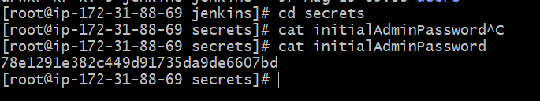

Copy the above password

78e1291e382c449d91735da9de6607bd

Enter into the

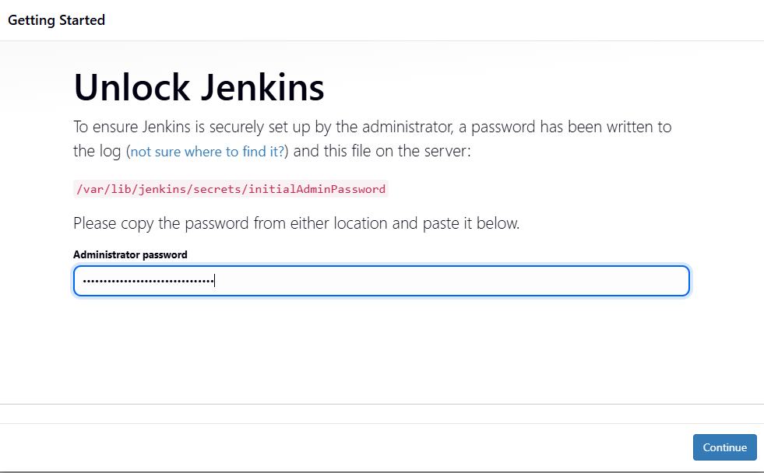

Click continue

**3) Create users called DevOps, Testing in Jenkins with Limited access.**

1. **Goto → manage jenkins → users then create devops and testing users**
2. 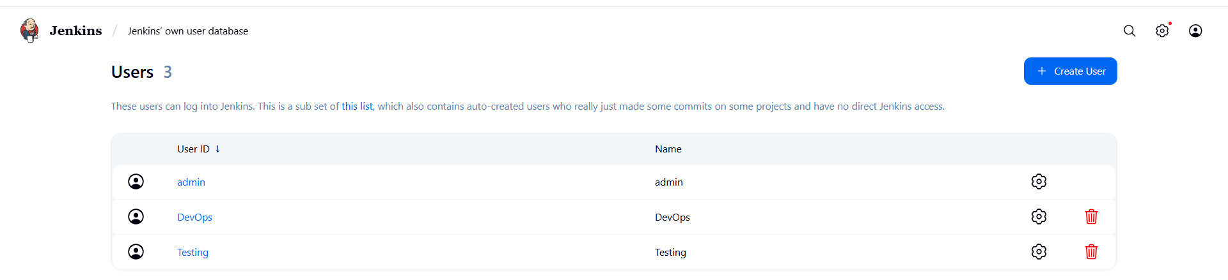
3. **Install plugin role-based authorization strategy**
4. 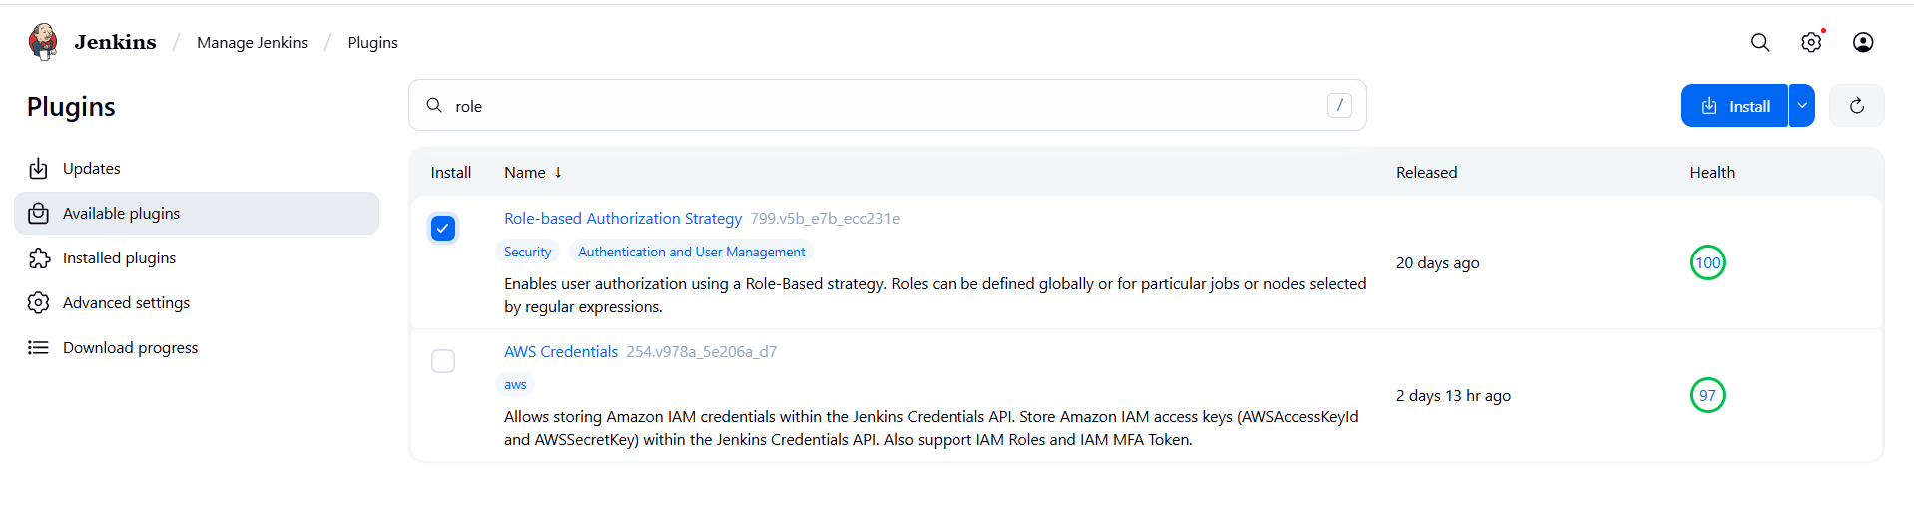
5. **Manage jenkins → security → authorization(project-based…..)**
6. 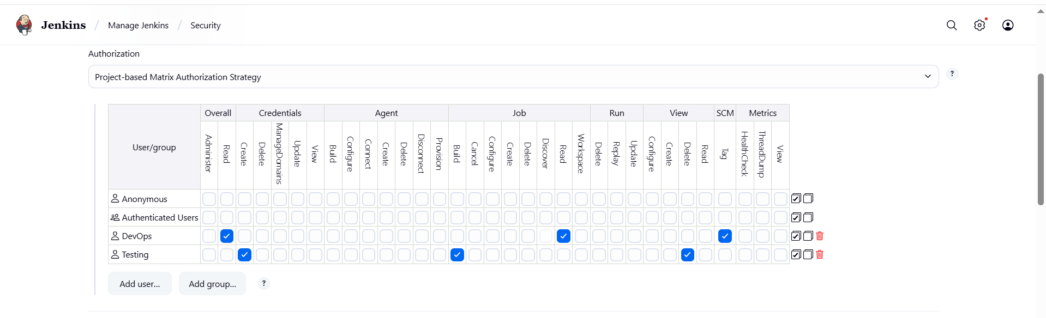
7. 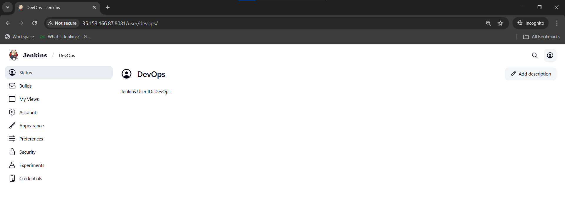
8. 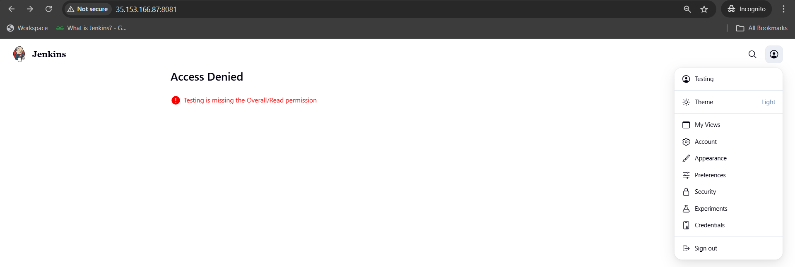

**4) Configure labels and restrict the jobs to execute based on label only.**

1. **Install GIT**
2. **Manage jenkins → system → create label Master**
3. **Create first job having label Master**
4. **Create second job without label Master**
5. **Create third job with wrong label hotfix**
6. **In each job → configure → build steps → execute shell → give seconds**
7. **I Got an issue with disk space**
8. 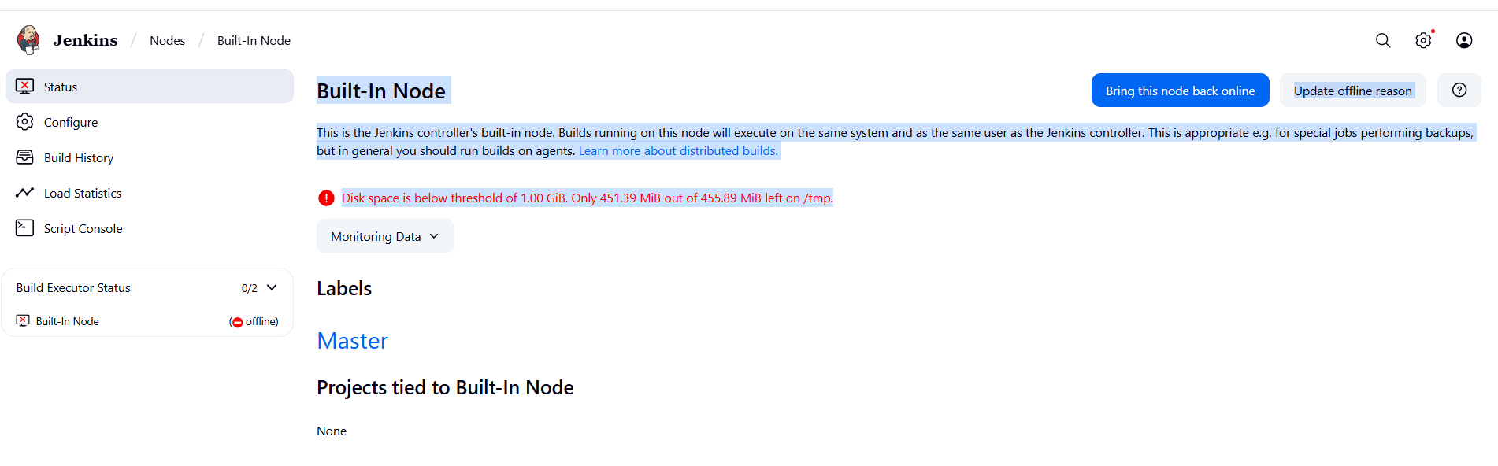
9. **Change Jenkins temporary directory (recommended)** 
   1. **Point Jenkins to use /var/lib/jenkins/tmp (on your main disk, which has ~18 GB free):**
   2. **Create a new tmp directory:  
      sudo mkdir -p /var/lib/jenkins/tmp**

**sudo chown -R jenkins:jenkins /var/lib/jenkins/tmp**

* 1. **Add below temp file → sudo systemctl edit jenkins**
  2. **[Service]**

**Environment="JAVA_OPTS=-Djava.io.tmpdir=/var/lib/jenkins/tmp"**

* 1. **Then reload**

**sudo systemctl daemon-reload**

**sudo systemctl restart jenkins**

1. **Install bitbucket plugin**
2. 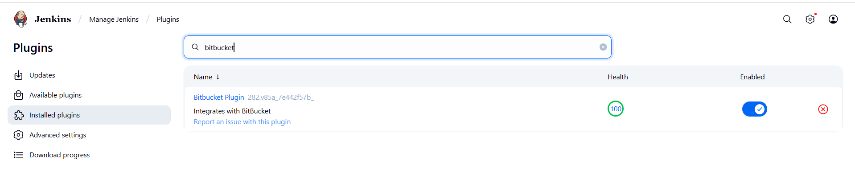
3. **First job only executed because its having label Master other jobs not connected to label Master**
4. 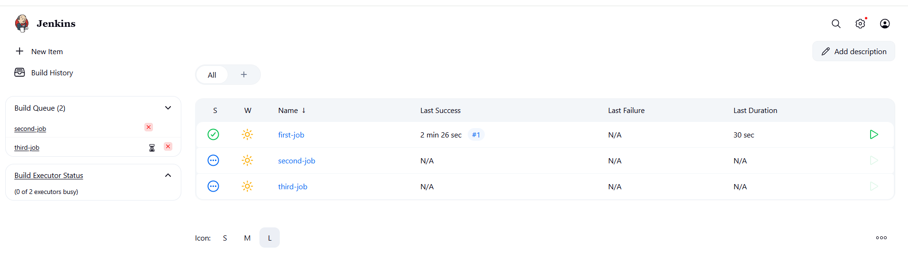

**5) Create Three sample jobs using the below URL.**

[**https://github.com/betawins/Techie_horizon_Login_app.git**](https://github.com/betawins/Techie_horizon_Login_app.git)

1. **Created three different jobs with different time stamps with label master i already in jenkins configured label as master.**
2. 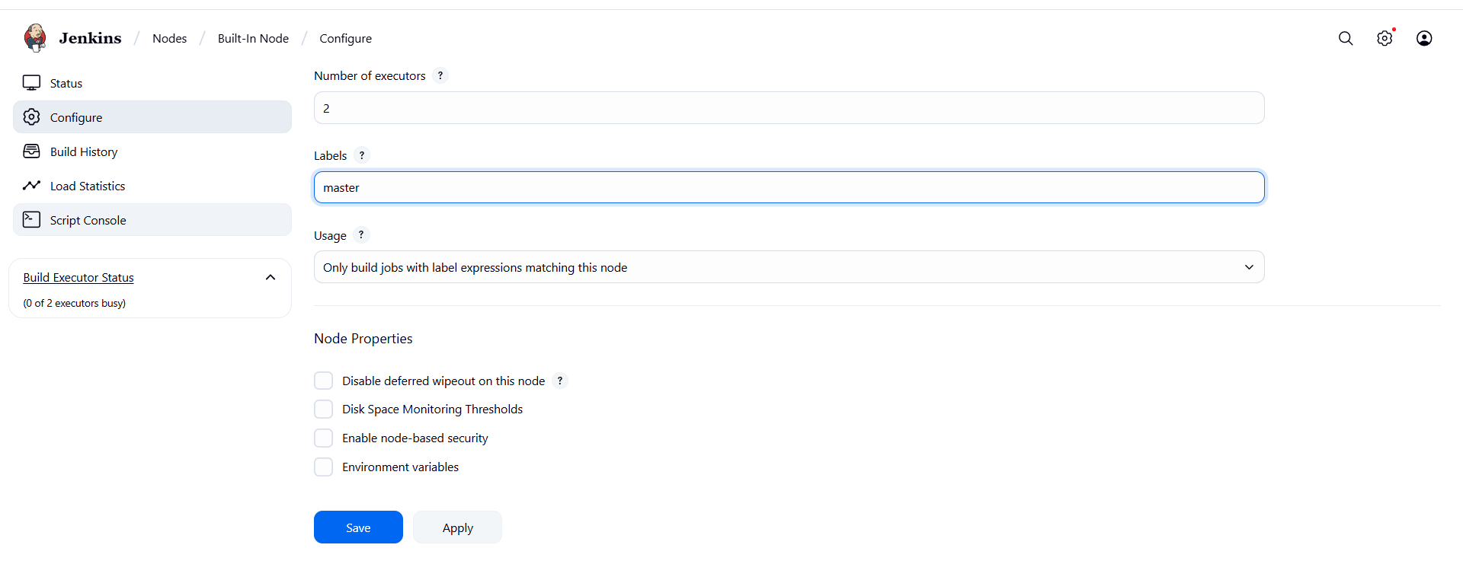
3. **Taken above url and once created then do build**
4. 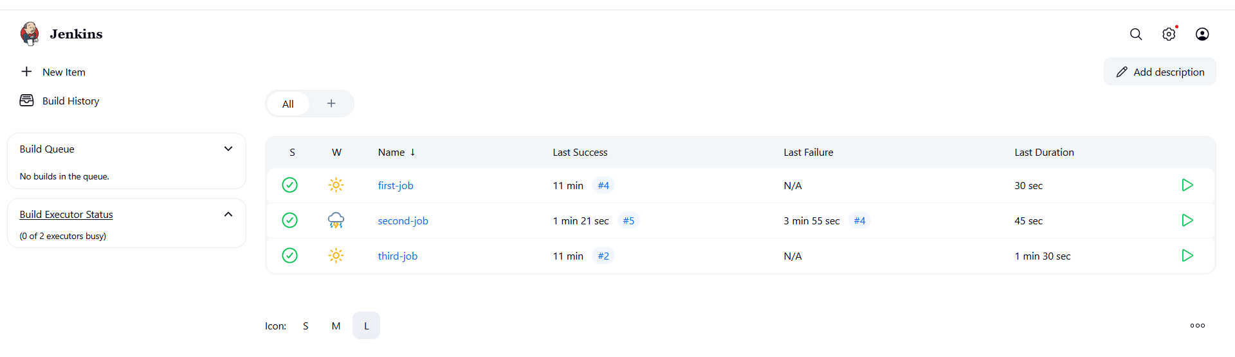

6 Q: **Create one Jenkins job using git hub Private repository.**

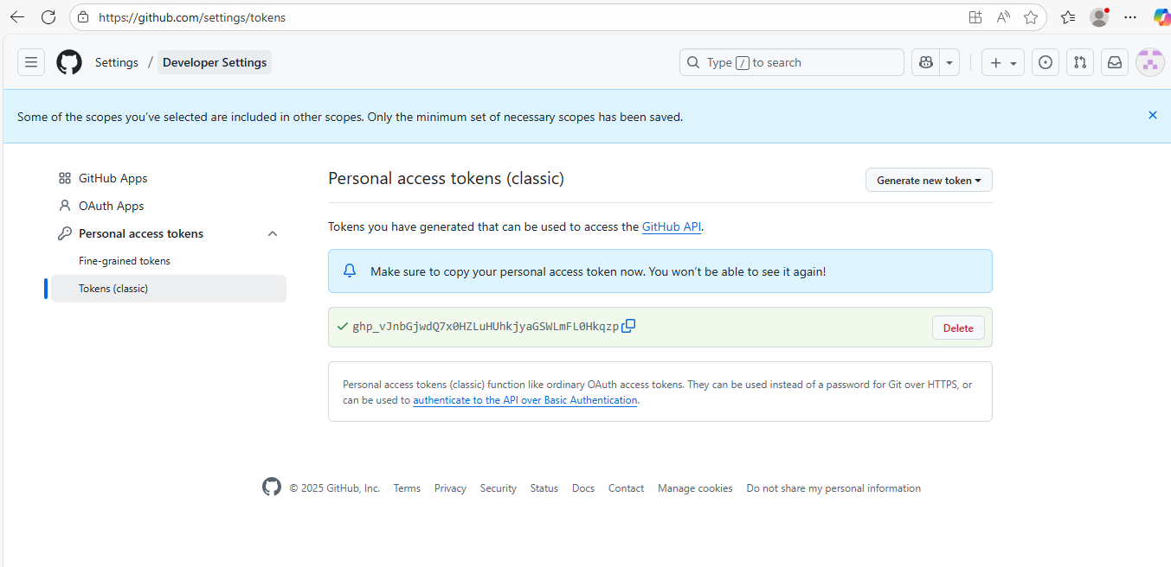

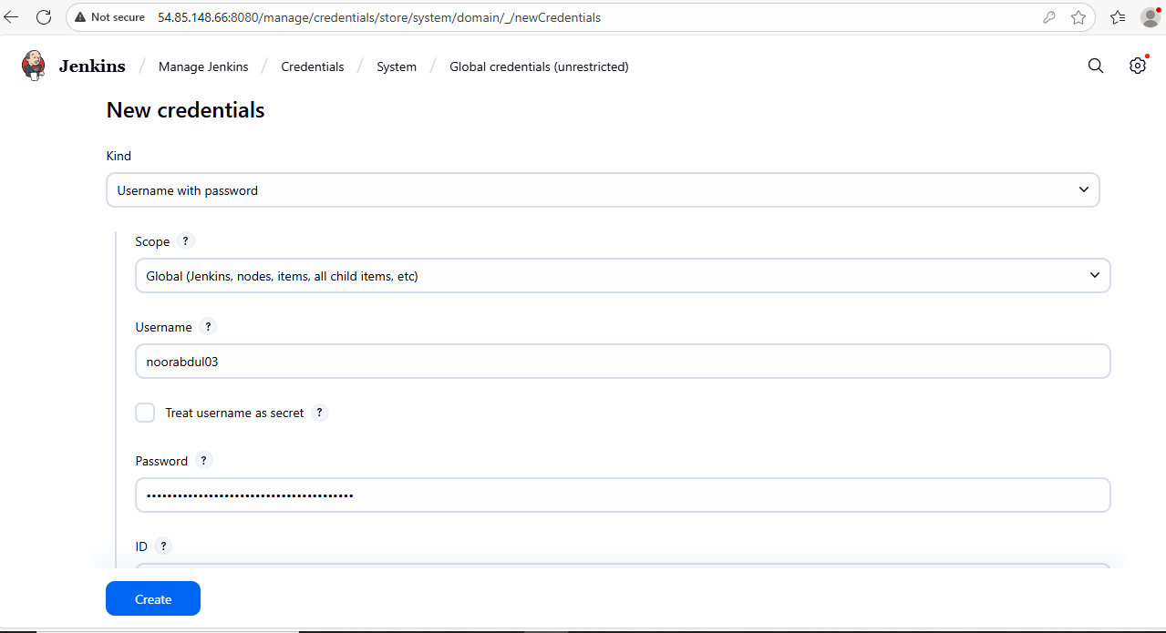

Click on create

Click on new item

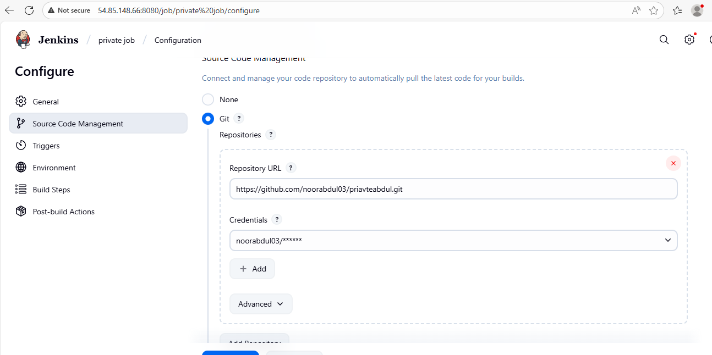

Make sure that you should have the same labels in all the three place i.e., restricted label, system configure, manage configure.

